**MS SQL EVALUATION**

**PREETHI_MANOJ_SQL.docx**

**Question set no:4**

A system to store Student mark list for maths and english for the entire academic year.

Student Id, Name ,Tel.No, gender etc, to be captured. Term wise and Test wise results of each subject to be stored.

Database :- student;

TABLES

*//created 2 tables: Students and Marks*

CREATE TABLE Students (

StudentID INT IDENTITY(1,1), Rollno int primary key,

Name NVARCHAR(100),

Gender CHAR(1),

TelNo NVARCHAR(15),

phoneno NVARCHAR(12),

);

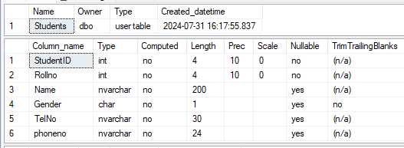

CREATE TABLE Marks (

MarkID INT PRIMARY KEY IDENTITY(1,1),

Rollno INT FOREIGN KEY REFERENCES Students(Rollno),

Term INT, Test VARCHAR(50),

englishMark INT, mathsmarks INT, totalmarks INT

);

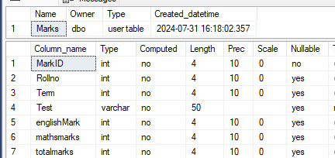

DATA INSERTION AND RETRIEVAL

INSERT INTO Students values (1,'preethi','f','2724162',''),

(2,'anu','f','2724962','9778257855'),(3,'manu','m','2924162',''),

(4,'jopu','m','2724002',''),(5,'mahi','m','2728962','9778457878'),

(6,'sam','m','2789919','922781988'),(7,'Rahul','m','235678',''), (8,'Raju','m','235678','6789292'),(9,'anup','m','282828','');

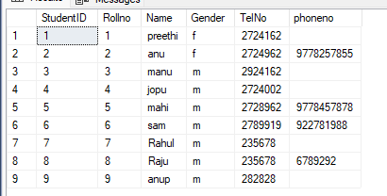

INSERT INTO Marks values (1,1,'semester',80,90,200),(2,1,'semester',70,90,170),

(3,2,'semester',80,70,290),(4,2,'revision',90,70,200),(5,2,'semester',86,79,189),

(6,1,'semester',80,67,279),(7,2,'semester',86,70,260),(8,1,'semester',86,67,180),

(9,2,'semester',96,82,200);

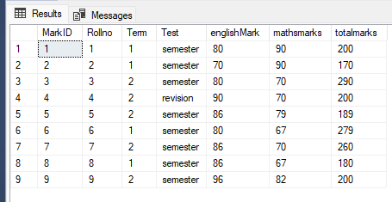

REPORTS

*–1. Student name and maths mark for term 1 for all students*

SELECT Students.Name, Marks.mathsmarks AS MathsMark

FROM Students

JOIN Marks ON Students.Rollno = Marks.Rollno

WHERE Marks.Term = 1;

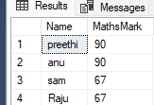

*--2. Student id and total marks of the student*

SELECT Students.StudentID, SUM(totalmarks) AS TotalMarks

FROM Students

JOIN Marks ON Students.Rollno = Marks.Rollno

GROUP BY Students.StudentID;

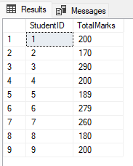

*--3. Student details for all students whose name starts with S or has P in their name. Sort in ascending order of name*

SELECT *

FROM Students

WHERE Name LIKE 'S%' OR Name LIKE '%P%'

ORDER BY Name ASC;

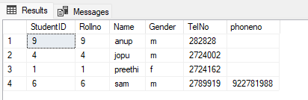

*--4. Student name and English mark for term 2 for all students. If mark is not there, show 'A' in the place of mark*

SELECT Students.Name, COALESCE(CAST(Marks.englishMark AS VARCHAR(10)), 'A') AS EnglishMark FROM Students Left JOIN Marks

ON Students.Rollno = Marks.Rollno AND Marks.Term = 2;

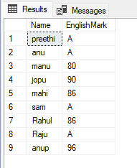

*--5. Student id and total marks of the student for all boys*

SELECT Students.StudentID, SUM(totalmarks) AS TotalMarks

FROM Students

JOIN Marks ON Students.Rollno = Marks.Rollno

WHERE Students.Gender = 'M'

GROUP BY Students.StudentID;

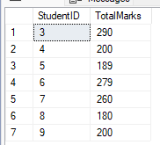

*--6. Student details for all students whose has phone number and whose name starts with A. Sort in ascending order of name*

SELECT *

FROM Students

WHERE phoneno IS NOT NULL AND phoneno != ' '

AND Name LIKE 'A%'

ORDER BY Name ASC;

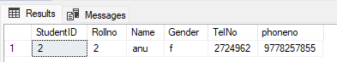

*--7. Student name and English mark for term 2 for all students. If mark is not there, show '0' in the place of mark*

SELECT Students.Name,

COALESCE(CAST(Marks.englishMark AS VARCHAR(10)), '0') AS EnglishMark

FROM Students LEFT JOIN Marks

ON Students.Rollno =Marks.Rollno AND Marks.Term = 2;

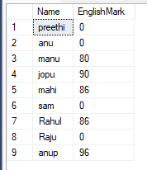

*--8. Student details for all boys who has the same mark for maths as 'Rahul'*

SELECT * FROM Students

JOIN Marks ON Students.Rollno = Marks.Rollno

WHERE Students.Gender = 'm' AND Marks.mathsmarks =

(SELECT mathsmarks FROM Marks WHERE Rollno =

(SELECT Rollno FROM Students WHERE Name = 'Rahul')

) order by mathsmarks;

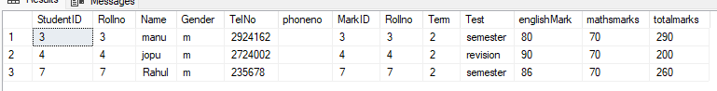

**RESULT**

Obtained all the required queries.